PIZZA SALES SQL QUERIES

A. KPI

1.Total Revenue

select sum(total_price) as Total_revenue from pizza_sales;

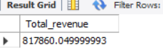

2.Average Order Value

select sum(total_price)/count(distinct order_id) as avg_order_value from pizza_sales;

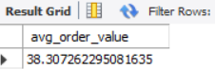

3.Total Pizza Sold

select sum(quantity) as Total_pizzas_sold from pizza_sales;

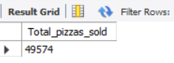

4.Total Order

select count(distinct order_id) as Total_order from pizza_sales;

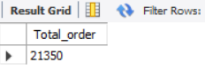

5.Average Pizza per order

select sum(quantity)/ count(distinct order_id) as Avg_pizzas_per_order from pizza_sales;

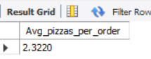

B. Charts Requirements

1.Daily Trend For total Orders

select DATENAME(dw,order_date) as Order_day,count(distinct order_id) as Ttal_Orders

from pizza_sales

group by DATENAME(dw,order_date)

order by DATENAME(dw,order_date)

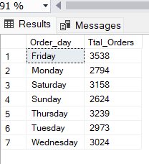

2.Monthly Trend for Total Orders

select DATENAME(Month,order_date) as Month_Name,count(distinct order_id) as Total_Orders

from pizza_sales

group by DATENAME(Month,order_date)

order by Total_Orders desc

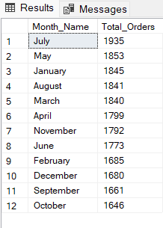

3.Percentage of sales by pizza category

select pizza_category ,sum(total_price) as Total_sales,

round(sum(total_price)*100/(select sum(total_price)

from pizza_sales where month(order_date) =1),2) as PCT from pizza_sales

where month(order_date) =1

group by pizza_category;

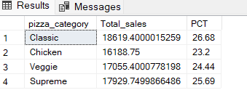

4.Percentage of Sales by Pizza Size

select pizza_size ,round(sum(total_price),2) as Total_sales,

round(sum(total_price)*100/(select sum(total_price)

from pizza_sales where datepart (quarter ,order_date)=1),2) as PCT from pizza_sales

where datepart (quarter ,order_date)=1

group by pizza_size

order by PCT desc;

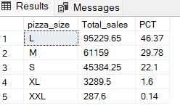

5.Top 5 Pizza by Revenue

select pizza_name ,sum(total_price) as Total_Revenue from Pizza_sales

group by pizza_Name

order by Total_Revenue desc limit 5;

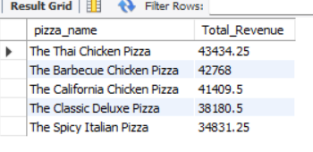

6.Bottom 5 pizza by Revenue

select pizza_name ,sum(total_price) as Total_Revenue from Pizza_sales

group by pizza_Name

order by Total_Revenue limit 5;

